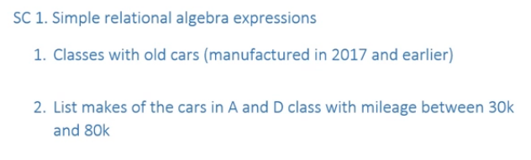
1. pi clsid(sigma year <= 2017 Car)
2.
------------------------------------------------------------------------------------------------------------------------

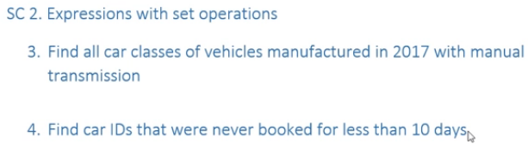
3.
4.
------------------------------------------------------------------------------------------------------------------------

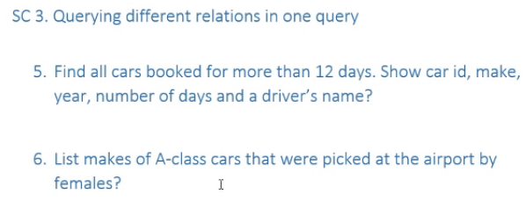

5. pi cid, make, year, days, name (sigma Res.days > 12 (Car ⨝ Res ⨝ Driver))
or
pi cid, make, year, days, name (Car ⨝ (sigma Res.days > 12 Res) ⨝ Driver)

6. pi make (sigma clsid='A' and pickAt='airport' and gender='f' (Car ⨝ Driver ⨝ Res))
------------------------------------------------------------------------------------------------------------------------

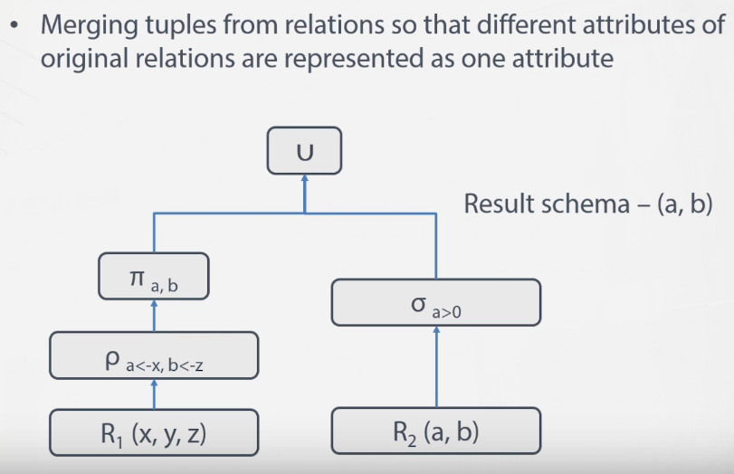
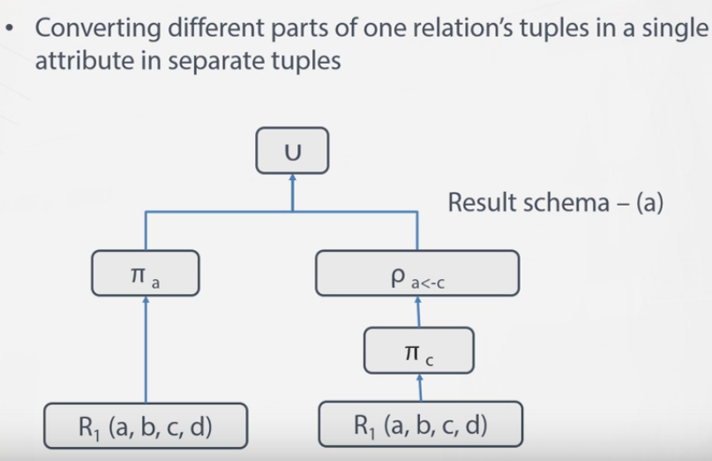

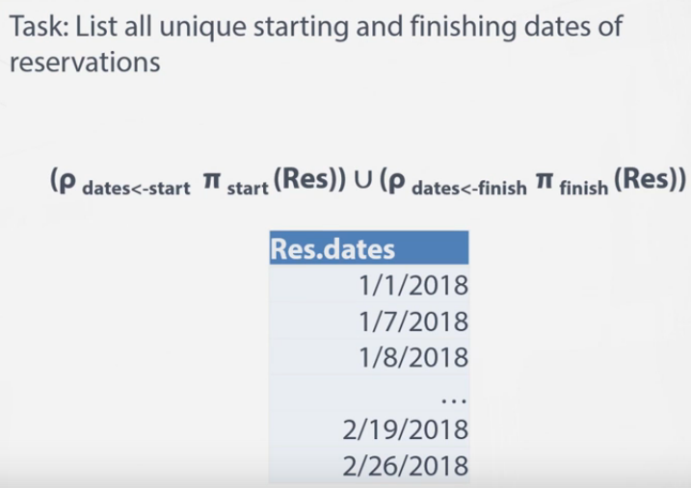

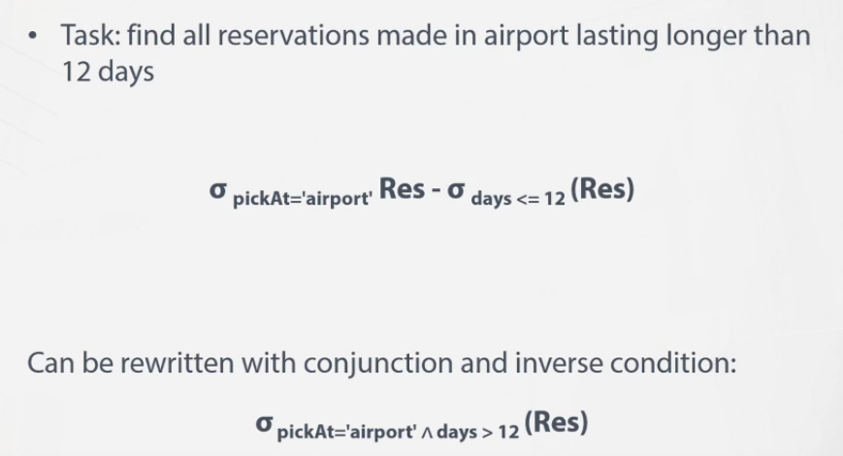

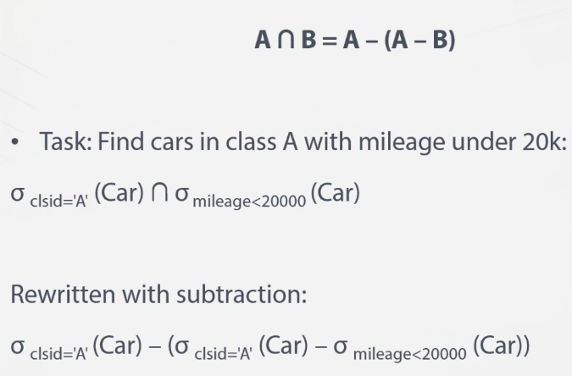
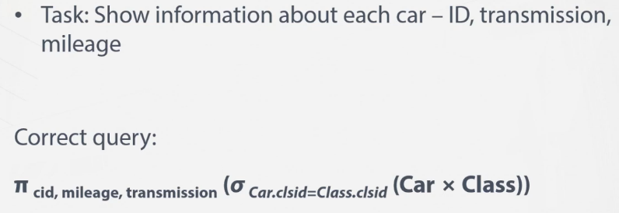
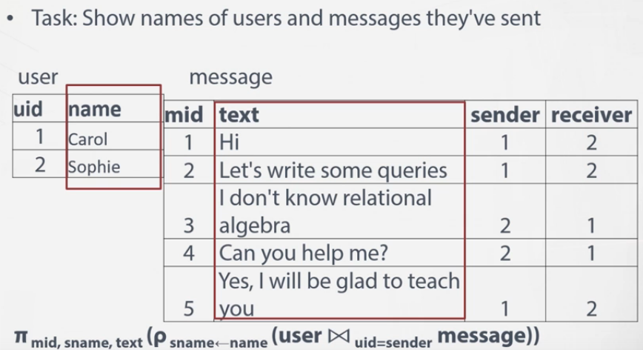
-------------------------------------------------------------------------------------------------------

Which guests (name and email) stayed in luxury double before living in a standard double room? Complete this query:

S = π rid (σ rtName='Standard double' RoomType ⨝ Room)
L = π rid (σ rtName='Luxury double' RoomType ⨝ Room)

π gName, email (
(ρ SSTART π gid, rid, start (S ⨝ Stay))
⨝ SSTART.gid = LSTART.gid and SSTART.start > LSTART.start
(ρ LSTART π gid, rid, start (L ⨝ Stay)) ⨝ Guest)

-------------------------------------------------------------------------------------------------------

Guests that booked a standard single and who ever stayed for less than 3 nights (not omly in a single room). Find IDs of these people. The correct expression is :
(π gid σ nights < 3 Stay) ∩ (π gid σ rtName = 'Standard single' (RoomType ⨝ Room ⨝ Stay))

-------------------------------------------------------------------------------------------------------

Which car was used repeatedly by the same driver? Modify this query to make it meet the requirements:

ρ A (π did, cid, bid Res) ⨯ ρ B (π did, cid, bid Res)

* Add select with AND: A.did = B.did
(we need to build pairs of reservations with the same driver)

* Add selection with AND: A.bid <> B.bid
(make sure the pair contains two different reservations)

* Add selection with AND: A.cid = B.cid
(we need pairs with the same cars)

* Join with the car relation
(Add data about the identified cars)

-------------------------------------------------------------------------------------------------------

Write an expression to find drivers (all attributes of a driver) who booked an 'A' class car and also a 'D' class.

Driver ⨝ (π did (Res ⨝ (σ clsid = 'A' (Car))) ∩ π did (Res ⨝ (σ clsid = 'D' (Car))))

-------------------------------------------------------------------------------------------------------

Does there exist a driver who always books cars of the same brand? Do not count drivers with one or zero reservation history.

π A.did ( ρ A (π bid, did Res) ⨝ A.bid<>B.bid ∧ A.did=B.did ρ B (π bid, did Res)) - π A.did (ρ A (pi did, make (Res ⨝ Car)) ⨝ A.did=B.did ∧ A.make<>B.make ρ B (pi did, make (Res ⨝ Car)))

-------------------------------------------------------------------------------------------------------

Which drivers booked only A-class cars? Find their Ids.

(π did (Res)) - π did (Res ⨝ (σ clsid <> 'A' (Car)))

-------------------------------------------------------------------------------------------------------

Find guests (id, name, email) who each time stayed the same number of nights or longer, than previously (similar to: Does there exist a guest who always stayed the same number of nights?)

π A.gid ( ρ A ( π sid, gid Stay) ⨝ A.sid <> B.sid ∧ A.gid=B.gid ρ B (π sid, gid Stay)) - π A.gid (ρ A (pi gid, nights Stay) ⨝ A.gid=B.gid ∧ A.nights <> B.nights ρ B (pi gid, nights Stay))

Next take an id, name, email:

pi gid, gName, email ((π A.gid ( ρ A ( π sid, gid Stay) ⨝ A.sid <> B.sid ∧ A.gid=B.gid ρ B (π sid, gid Stay)) - π A.gid (ρ A (pi gid, nights Stay) ⨝ A.gid=B.gid ∧ A.nights <> B.nights ρ B (pi gid, nights Stay))) ⨝ Guest)

